**THENMOZHI R 231901064**

**EXERCISE 13**

**Detection of real-time threats, analyse recorded traffic files and identify anomalies**

**Aim:** To learn how to use Snort for real-time threat detection, traffic analysis, and anomaly identification using both live and recorded network data.

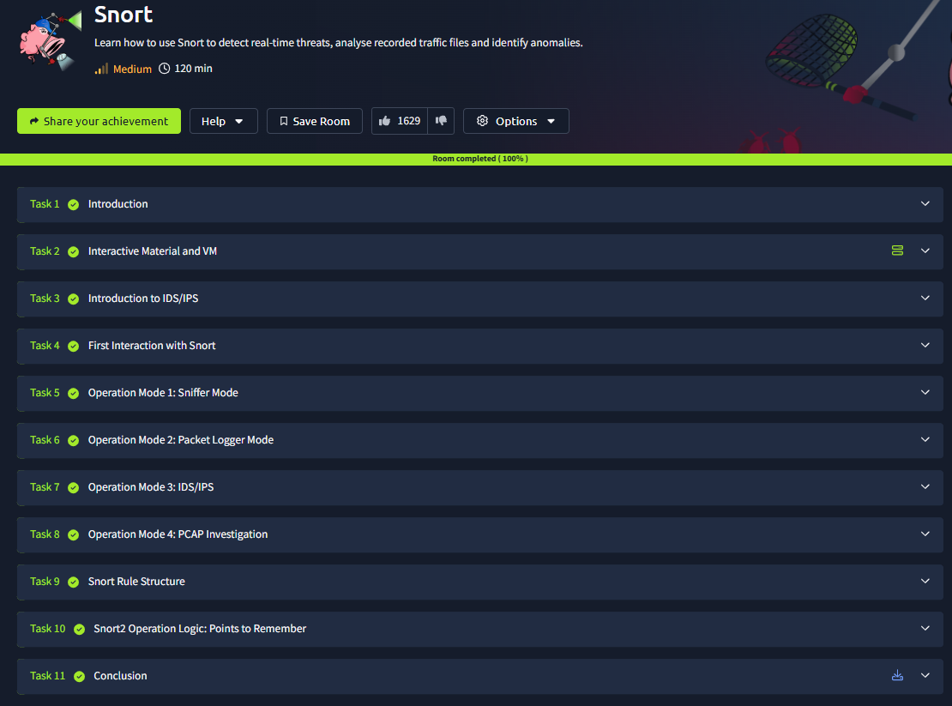



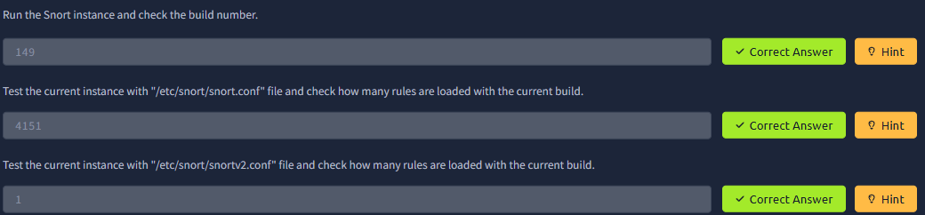



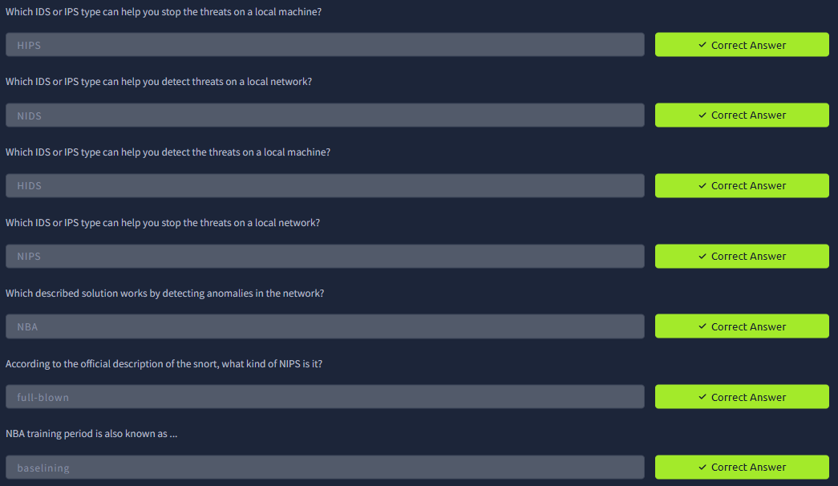

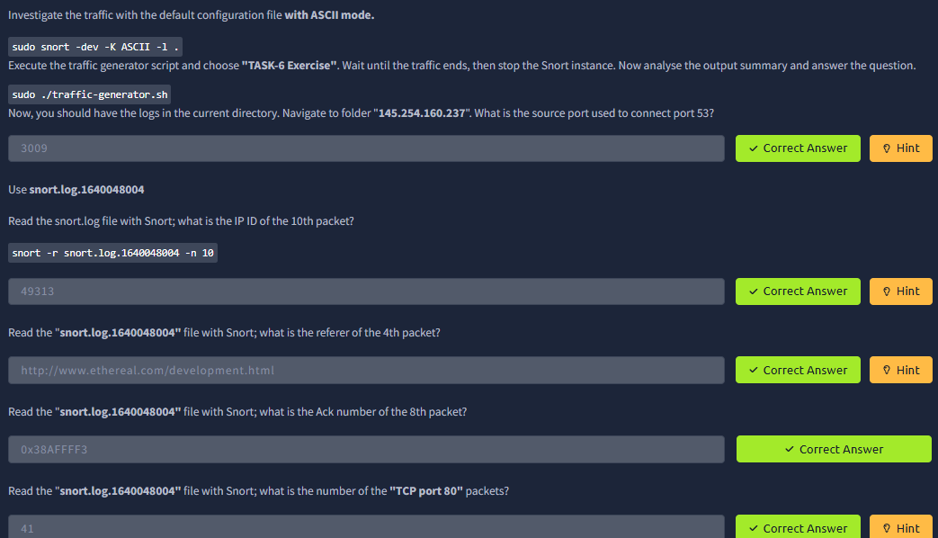

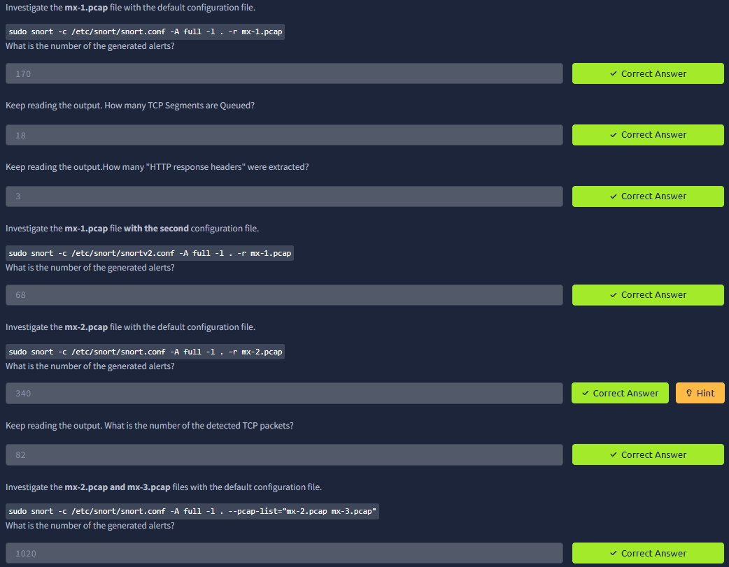

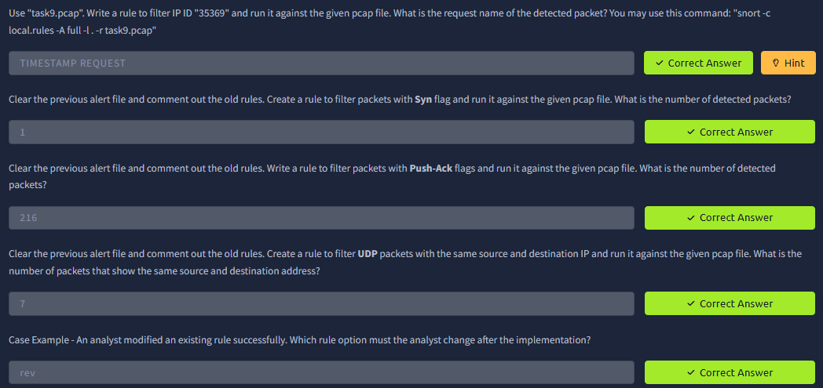

**Result:** Successfully configured Snort to detect live threats, analyzed pcap traffic files, and identified suspicious patterns and anomalies in network behavior.